**Daniel Williamson**

**Project #3**

**2/26/16**

**CS 200**

Project Overview

Purpose:

The purpose of this project was to have a user input two arbitrary integers and then apply various bitwise operations to said integers. Such as: & (and), | (or), ^ (xor), ~ (not), >> (right shift), and << (left shift).

Approach:

To begin this project I immediately went to the internet to gain an understanding of how to program on a basic level in C. After I read up on it, I began to plan how the program should run. I decided on making a method for each of the three types of data we were working on, decimal, hexadecimal and binary. Once that was completed I began to make my Main method were all the user input would be collected and all the output for the GUI would be. And lastly I added a getch() so the .exe would not close immediately after executing it.

Results

These are my results:

This is a depiction of my three methods used to convert the users input into other data types.

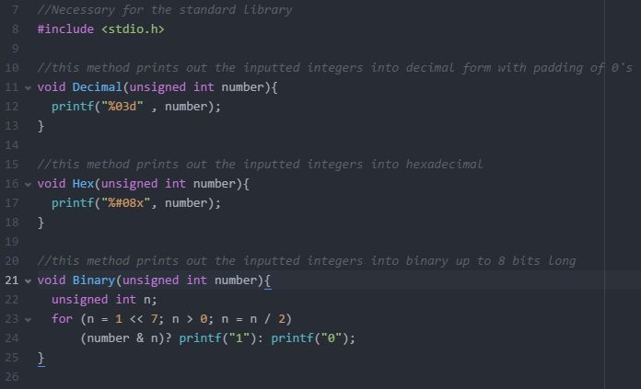

This is a depiction of the Main method used. First we assign the two numbers being taken in by the user. Next we being setting up the output for the GUI to make it look all pretty. And lastly the getch(); to keep the .exe from terminating.

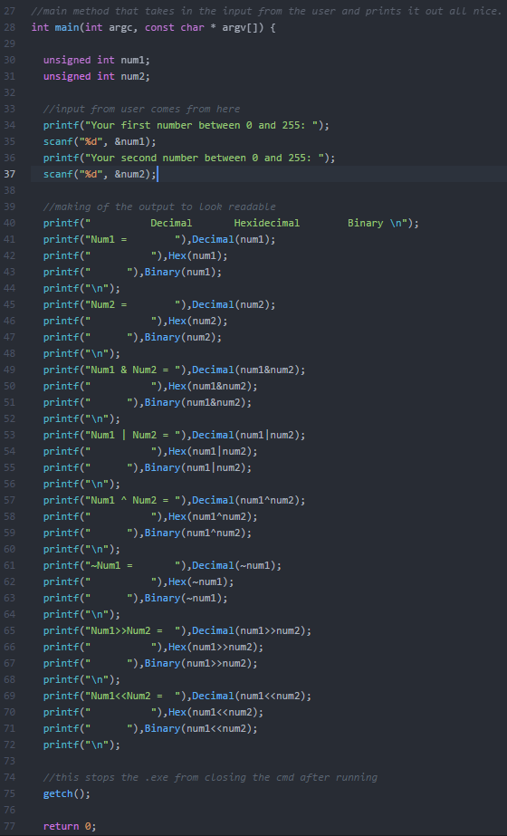

Testing:

Knowing that 10 in hex is Ah and in binary its 1010b.

And knowing that 6 in hex is 6h and in binary its 0110b.

We can see that the output for each is correct.

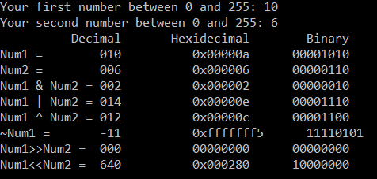

Furthermore, knowing that:

10 & 6 should be 2h in hex and 0010b in binary,

And 10 | 6 should be Eh in hex and 1110b in binary,

And 10 ^ 6 should be Ch in hex and 1100b in binary,

And ~6 should be F5h in hex and 11110101b in binary (which is wrong),

And 10>>6 should be 0h in hex and 0000b in binary,

And 10<<6 should be 280h in hex and 10000000b in binary,

We can clearly see in the depiction above that the code is once again correct. However, unfortunately for the ~num1, it is incorrect.

Conclusion

In conclusion this was an extremely difficult project. I relied heavily on the internet for programming in C. However, because of that I am now more proficient in programming in C. At least more then I was. I am not entirely sure if getch() is a correct way to leave the .exe running. It was something I found on the internet, because immediately after entering two inputs the cmd would close on me. Another difficulty was the NOT bitwise operation, I unfortunately could not get this operation to work properly. The numbers were coming out negative and I tried using unsigned int for all of my variables which still did not solve the problem.